Install on Cloud Printer whil be only through Google Chrome in PC!
Other Browse for example Internet Explorer don’t !!!
Steps:
- On PC
1. Install Google Chrome
2. You must read printers through “ chrome://devices “ .
3. In this wab page click “Sign in” /not click “Add printers”/ and you see all printers.
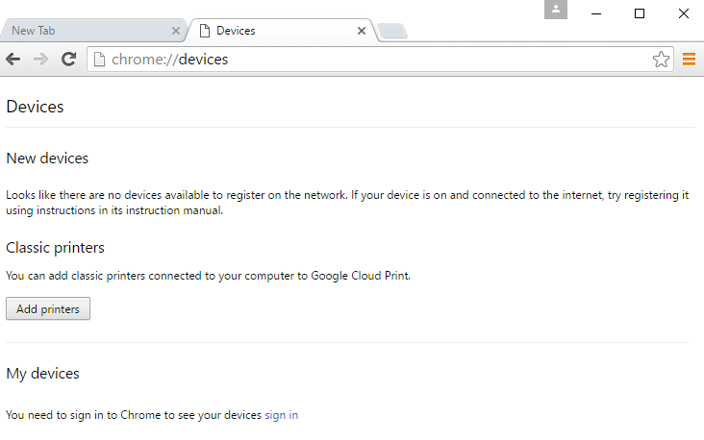
4. And that is all.

- On Tablete
- Click “ Print ” to next image

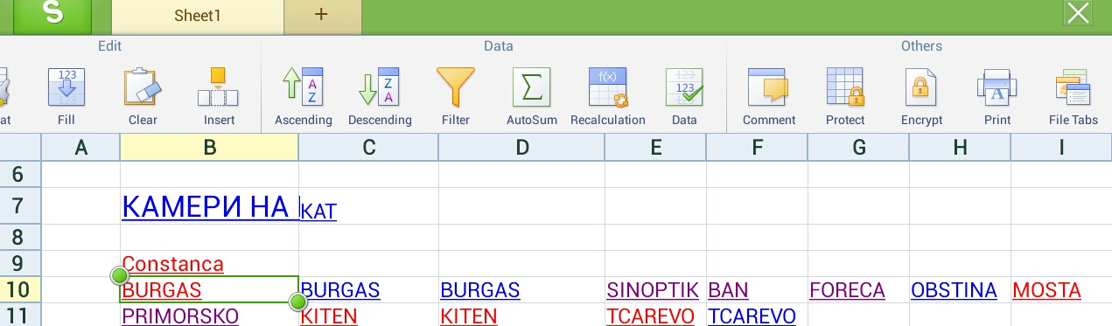

- Click “Cloud Printer ” to next image

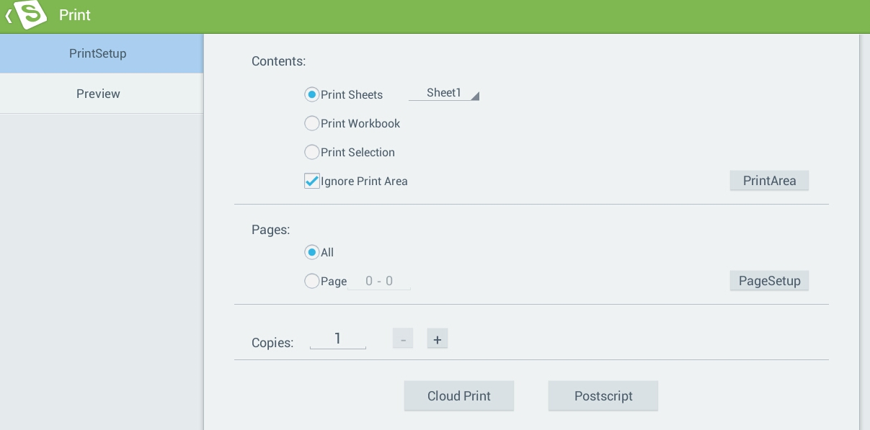

- Click “Continue ” to next image

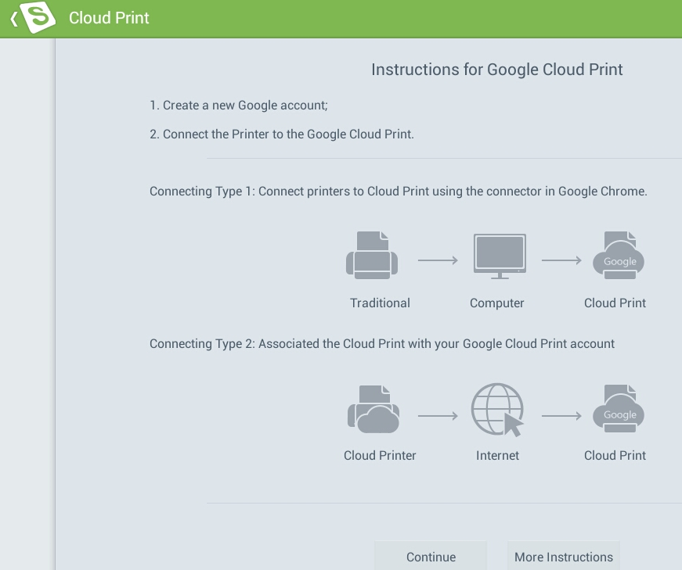

- This image if All Righ.
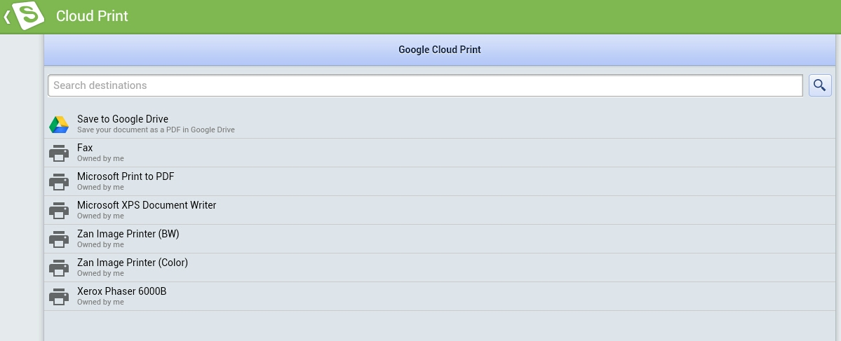

- If other image go point I.

